EXPT NO:03 | EDA-DATA INSPECTION AND ANALYSIS

AIM:
To perform Exploratory Data Analysis (EDA) and data cleaning on the AI Impact on Jobs dataset to identify employment and AI-related patterns, handle missing values, remove duplicate records, detect inconsistencies and outliers, and prepare the dataset for Machine Learning.

PROCEDURE:
- Import the required Python libraries such as Pandas, NumPy, Matplotlib, and Seaborn.
- Load the AI Impact on Jobs 2030 dataset using Pandas.
- Display the first few records and check the dataset shape.
- Examine the data types and dataset information.
- Check for missing or null values.
- Handle missing values using suitable methods.
- Identify and remove duplicate records.
- Check for incorrect or inconsistent values in categorical and numerical columns such as Job Title, Industry, Country, Education Level, Automation Level, Company Size, AI Tool Usage, Upskilling Needed, and Hiring Trend.
- Detect possible outliers in numerical features such as Years of Experience, AI Replacement Risk, Future Demand Score, Average Salary, Job Growth, Work Hours, Performance Score, and Job Satisfaction using statistical methods and visualization.
- Perform statistical analysis using the describe() function.
- Visualize important features using graphs and charts.
- Analyze correlations between numerical features using a heatmap.
- Examine the distribution of the target variable AI Replacement Risk.
- Analyze the relationship between AI Replacement Risk and important features such as Automation Level, Years of Experience, Future Demand Score, and AI Tool Usage.
- Save the cleaned AI Impact on Jobs dataset for further analysis and Machine Learning.

CODE:
import pandas as pd
import numpy as np
import matplotlib.pyplot as plt
import seaborn as sns

df = pd.read_csv("AI_Impact_on_Jobs_2030.csv")

print("First 5 Records")

print(df.head())

print("\nDataset Shape")
print(df.shape)

print("\nDataset Information")
df.info()

print("\nMissing Values")
print(df.isnull().sum())

print("\nDuplicate Records:", df.duplicated().sum())

df = df.drop_duplicates().dropna()

print("\nStatistical Summary")
print(df.describe())

plt.figure(figsize=(7, 5))
sns.histplot(df["AI_Replacement_Risk"], bins=20, kde=True)
plt.title("AI Replacement Risk Distribution")
plt.xlabel("AI Replacement Risk")
plt.ylabel("Number of Jobs")
plt.show()

plt.figure(figsize=(7, 5))
sns.boxplot(x=df["Automation_Level"], y=df["AI_Replacement_Risk"])
plt.title("Automation Level vs AI Replacement Risk")
plt.show()

plt.figure(figsize=(7, 5))
sns.scatterplot(
x=df["Years_Experience"],
y=df["AI_Replacement_Risk"]
)
plt.title("Experience vs AI Replacement Risk")
plt.xlabel("Years of Experience")
plt.ylabel("AI Replacement Risk")
plt.show()

numeric_data = df.select_dtypes(include=np.number)

plt.figure(figsize=(10, 7))
sns.heatmap(
numeric_data.corr(),
annot=True,

cmap="coolwarm",
fmt=".2f"
)
plt.title("Correlation Heatmap")
plt.show()

df.to_excel(
"Cleaned_AI_Impact_on_Jobs_2030.xlsx",
index=False
)

print("\nCleaned dataset exported to Excel successfully!")

OUTPUT:

First 5 Records
Employee_ID Job_Title Industry Country Education_Level \
0 AIJ-100000 Data Engineer Healthcare Japan PhD
1 AIJ-100001 Healthcare Analyst Retail UK Bachelor
2 AIJ-100002 HR Specialist Education Canada High School
3 AIJ-100003 Cybersecurity Analyst Government UK Bachelor
4 AIJ-100004 Healthcare Analyst Education UAE PhD

Years_Experience AI_Replacement_Risk Future_Demand_Score \
0 1 0.25 0.78
1 24 0.73 0.33
2 21 0.80 0.69
3 5 0.29 0.94
4 20 0.11 0.92

Remote_Work_Possibility Average_Salary_USD \
0 Yes 207392
1 No 140785
2 Yes 124800
3 No 199878
4 No 178682

Required_Skills Automation_Level \
0 Python, Communication, Deep Learning Low
1 Deep Learning, Azure, Communication, TensorFlo... Low
2 Kubernetes, Cloud Computing, TensorFlow, SQL, ... Medium
3 Excel, Kubernetes, Prompt Engineering, Leadership Medium
4 SQL, Leadership, TensorFlow, Cybersecurity Low

Job_Growth_2030 Work_Hours_Per_Week Company_Size AI_Tool_Usage \
0 3 37 Enterprise High
1 -5 42 Startup Moderate
2 -5 57 Startup Low
3 7 59 Enterprise High
4 6 34 Startup High

Performance_Score Upskilling_Needed Job_Satisfaction Hiring_Trend_2026
0 2.08 Yes 3.86 Growing
1 4.54 No 4.23 Growing
2 3.14 No 3.54 Stable
3 3.67 No 4.37 Declining
4 3.68 No 3.99 Stable

Dataset Shape
(3000, 20)

Dataset Information
<class 'pandas.core.frame.DataFrame'>
RangeIndex: 3000 entries, 0 to 2999
Data columns (total 20 columns):
# Column Non-Null Count Dtype
--- ------ -------------- -----
0 Employee_ID 3000 non-null object
1 Job_Title 3000 non-null object
2 Industry 3000 non-null object
3 Country 3000 non-null object
4 Education_Level 3000 non-null object
5 Years_Experience 3000 non-null int64
6 AI_Replacement_Risk 3000 non-null float64
7 Future_Demand_Score 3000 non-null float64
8 Remote_Work_Possibility 3000 non-null object
9 Average_Salary_USD 3000 non-null int64
10 Required_Skills 3000 non-null object
11 Automation_Level 3000 non-null object
12 Job_Growth_2030 3000 non-null int64
13 Work_Hours_Per_Week 3000 non-null int64
14 Company_Size 3000 non-null object
15 AI_Tool_Usage 3000 non-null object
16 Performance_Score 3000 non-null float64
17 Upskilling_Needed 3000 non-null object
18 Job_Satisfaction 3000 non-null float64
19 Hiring_Trend_2026 3000 non-null object
dtypes: float64(4), int64(4), object(12)
memory usage: 468.9+ KB

Missing Values
Employee_ID 0
Job_Title 0
Industry 0
Country 0
Education_Level 0
Years_Experience 0
AI_Replacement_Risk 0
Future_Demand_Score 0
Remote_Work_Possibility 0
Average_Salary_USD 0
Required_Skills 0
Automation_Level 0
Job_Growth_2030 0
Work_Hours_Per_Week 0
Company_Size 0
AI_Tool_Usage 0
Performance_Score 0
Upskilling_Needed 0
Job_Satisfaction 0
Hiring_Trend_2026 0
dtype: int64

Duplicate Records: 0

Statistical Summary
Years_Experience AI_Replacement_Risk Future_Demand_Score \
count 3000.000000 3000.000000 3000.000000
mean 12.383000 0.502910 0.601203
std 7.528958 0.261293 0.226674
min 0.000000 0.050000 0.200000
25% 6.000000 0.280000 0.420000
50% 12.000000 0.500000 0.600000
75% 19.000000 0.730000 0.800000
max 25.000000 0.950000 0.990000

Average_Salary_USD Job_Growth_2030 Work_Hours_Per_Week \
count 3000.000000 3000.000000 3000.000000
mean 126641.746667 17.238333 44.773333
std 55405.053057 16.230322 8.926469
min 30221.000000 -10.000000 30.000000
25% 77262.000000 3.000000 37.000000
50% 127660.500000 17.000000 45.000000
75% 174811.750000 31.000000 52.000000
max 219998.000000 45.000000 60.000000

Performance_Score Job_Satisfaction
count 3000.000000 3000.000000
mean 3.514643 3.026167
std 0.873375 1.146361
min 2.000000 1.000000
25% 2.760000 2.060000
50% 3.540000 3.025000
75% 4.270000 4.010000
max 5.000000 5.000000

Cleaned dataset exported to Excel successfully!

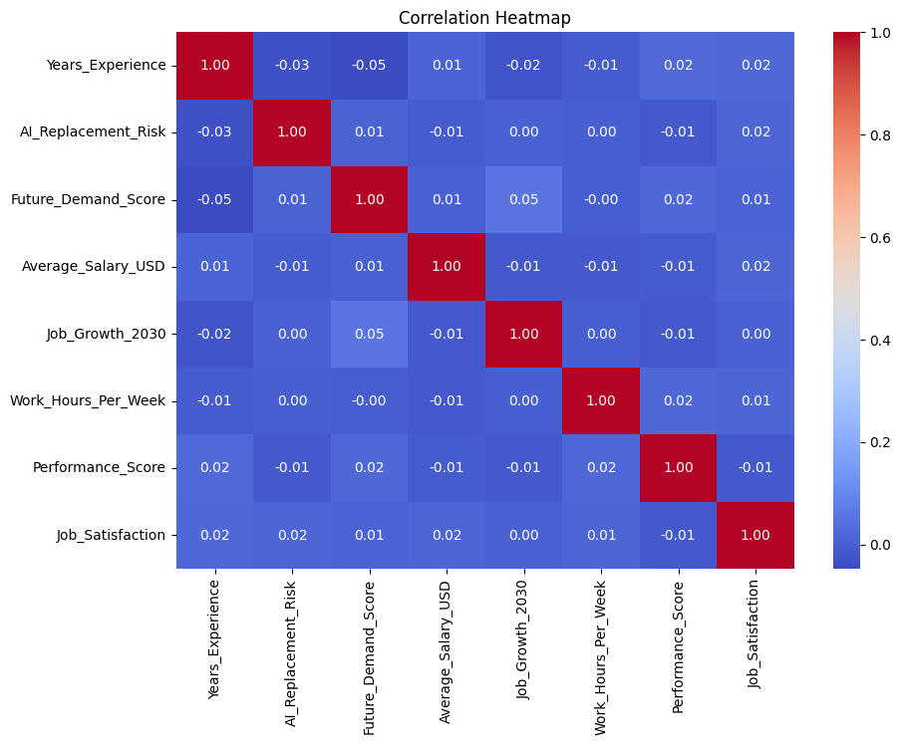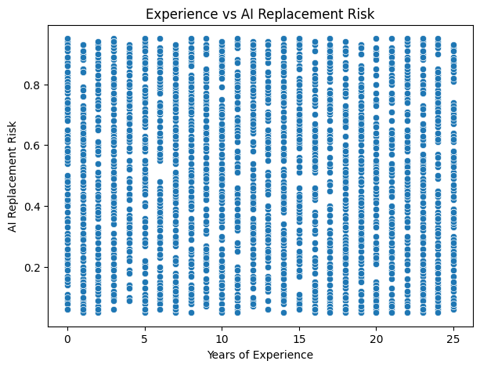

RESULT:

